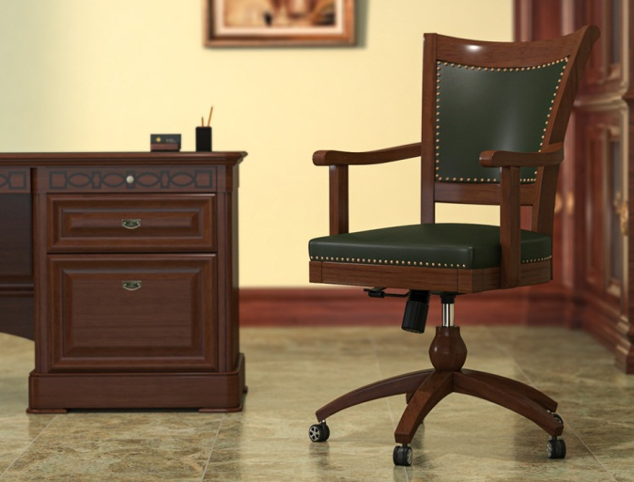

* Leatherette Padded Seat & back (Green)
* Base in Mahogany Wood
* Height Adjustable (Gas Lift)
* Torsion Bar Basic Tilt Mechanism
* 360 Rotation
* Repro Mahagony Polish Finish

Size:

* 23 W x 22 D x 37 H (Inches)
* 600 W x 560 D x 950 H (mm)

Note: The actual colours may vary from those shown depending on the device you are using to view the product or the angle of the item is photographed.

